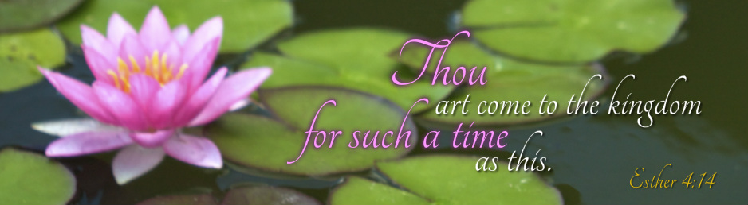

Dear Sister,
You are invited to speak at the sixth annual A.S.I.A. Women’s Conference to be held in Hong Kong on March 13-15, 2014. As you may know, this conference is attended primarily by English-speaking sisters living in branches and wards throughout Asia. Although the Church does not sponsor this conference, it has been approved by the Asia Area Presidency and will by held at the Church Administration Building in Wanchai, on Hong Kong Island.
The theme of our 2014 conference is “Thou are come to the Kingdom for such a time as this” Esther 4:14
Each class session will last forty-five minutes. Speakers are asked to give their presentation only once. During the other class sessions, you may attend the presentations of others. Time is critical so make sure you are within the limit.
The Women’s Conference committee would like you to understand why we chose the theme so that it may inspire you in your presentation and to also help you with choosing your topic and title. The committee felt that each of us needs to understand the critical role we, as sisters, can play in helping to "hasten the work" where ever we are and whatever situation we are in. When we individually seek to discover why the Lord has brought each of us to where we are now “for such a time as this”, with our unique talents and experience and situations, we can also discover how we personally can be a vital instrument in His hands to hasten the work and build the Kingdom in whatever corner of the earth he has placed us.

I have previously contacted each of you and received a positive response for being willing to speak during our conference break out sessions. It is important that the committee receive information from you so that we can post it to the website as soon as possible.
I will need to have a few things from you on or before February 10, 2014
- Title of Presentation
- A one to two sentence summary of presentation
- A current photo – either single or with family
- A short Bio – One to two paragraphs.
  - For ideas check out the website for the speakers from last year
- Any presentation needs (projector, microphone, piano, etc.)
We hope that all personations will bless the lives of the sisters who attend and help them to increase their faith and personal righteousness, influence them to strengthen their families and homes, and inspire them to serve the Lord and His children. We hope that you are inspired and directed by the Lord in your presentation and that this is an uplifting experience for all participating.
We look forward to hearing from you, and feel free to contact with any questions.
Kind regards,
Heidi Gailey
ASIA Women’s Conference Committee
heidigailey@gmail.com

